UML DIAGRAM

SUBMITTED BY;
SNEHA MARTIN
24PMC151

PROJECT: DONATION MANAGEMENT SYSTEM
1. UML DIAGRAMS
1.1 USE CASES
1.1.1 USE CASE 1: REGISTER NEW ACCOUNT
- Use Case ID: UC01
- Use Case Name: User Registration
- Description: A new user registers as a Donor or Receiver to access the system.
- Primary Actor: User
- Secondary Actor: None
Preconditions:
- User is not already registered.
Postconditions:
- A new user account is created successfully.
Main Flow:
- User opens the registration page
- User enters name, email/phone number, role, and password.
- User submits the form.
- System validates the details.
- System creates the account.
- User is redirected to login.
Alternative Flow:
- If the email already exists or the input is invalid, an error is displayed.
- User corrects the input and resubmits.

1.1.2 USE CASE 2: USER LOGIN
- Use Case ID: UC02
- Use Case Name: User Login
- Description: Registered users log in using secure authentication (JWT).
- Primary Actor: User (Donor / Receiver / Admin)
- Secondary Actor: None
Preconditions :
- User must be registered.
Postconditions:
- User is authenticated and logged in.
Main Flow:
- User navigates to login page.
- User enters credentials.
- System verifies credentials.
- System issues authentication token.
- User is redirected to dashboard.
Alternative Flow:
- If credentials are invalid, error is shown.
- User retries login.

1.1.3 USE CASE 3: CREATE ITEM REQUEST
- Use Case ID: UC03
- Use Case Name: Create Item Request
- Description: Receiver submits a request for required items.
- Primary Actor: Receiver
- Secondary Actor: None
Preconditions:
- Receiver must be logged in.
Postconditions:
- Item request is created with status Pending.
Main Flow:
- Receiver navigates to request page.
- Receiver enters item details (name, category, condition, quantity, usage duration).
- Receiver submits the request.
- System validates the request logic.
- System saves the request
- Confirmation messages are displayed.
Alternative Flow:
- If data is invalid, the system shows error.
- Receiver corrects and resubmits.

1.1.4 USE CASE 4: VIEW OWN ITEM REQUESTS
- Use Case ID: UC04
- Use Case Name: View Request History
- Description: Receiver views only their own item requests.
- Primary Actor: Receiver
- Secondary Actor: None
Preconditions :
- Receiver must be logged in.
Postconditions:
- Receiver’s request list is displayed.
Main Flow:
- Receiver opens “My Requests”.
- System filters requests by logged-in receiver.
- System displays request details and status.

1.1.5 USE CASE 5: CREATE DONATION
- Use Case ID: UC05
- Use Case Name: Create Donation
- Description: Donor lists items for donation with images.
- Primary Actor: Donor
- Secondary Actor: Cloud Storage Service
Preconditions:
- Donor must be logged in.
Postconditions:
- Donation is created successfully.
Main Flow:
- Donor navigates to donation creation page.
- Donor enters item details.
- Donor uploads item images.
- System uploads images to cloud storage.
- System saves donation data.
- Confirmation is shown.
Alternative Flow:
- If image upload fails, error is displayed.
- Donor retries upload.

4.1.6 USE CASE 6: VIEW OWN DONATIONS
- Use Case ID: UC06
- Use Case Name: View Donations
- Description: Donor views donations created by them.
- Primary Actor: Donor
- Secondary Actor: None
Preconditions:
- Donor must be logged in.
Postconditions:
- Donor’s donation list is displayed.
Main Flow:
- Donor opens “My Donations”.
- System filters donations by logged-in donor.
- System displays donation details.

4.1.7 USE CASE 7: UPDATE DONATION
- Use Case ID: UC07
- Use Case Name: Update Donation
- Description: Donor updates donation details before assignment.
- Primary Actor: Donor
- Secondary Actor: None
Preconditions:
- Donation exists and is not fulfilled.
Postconditions:
- Donation details are updated.
Main Flow:
- Donor selects a donation.
- Donor edits donation details.
- System validates changes.
- System saves updates.

4.1.8 USE CASE 8: VIEW ALL ITEM REQUESTS
- Use Case ID: UC08
- Use Case Name: View All Requests
- Description: Admin views all receiver item requests.
- Primary Actor: Admin
- Secondary Actor: None

Preconditions:
- Admin must be logged in.
Preconditions:
- All item requests are displayed.
Main Flow:
- Admin opens request management page.
- System retrieves all requests.
- System displays request list.

4.1.9 USE CASE 9: APPROVE OR REJECT REQUEST
- Use Case ID: UC09
- Use Case Name: Manage Item Request
- Description: Admin approves or rejects item requests.
- Primary Actor: Admin
- Secondary Actor: None
Preconditions:
- Request status is Pending.
Postconditions:
- Request status updated to Approved or Rejected.
Main Flow:
- Admin selects a pending request.
- Admin approves or rejects it.
- System updates request status.
- Receiver is notified.

4.1.10 USE CASE 10: MATCH DONATION WITH REQUEST
- Use Case ID: UC10
- Use Case Name: Match Donation
- Description: Admin assigns a suitable donation to an approved request.
- Primary Actor: Admin
- Secondary Actor: None
Preconditions:
- Request is approved.
- Donation is available.
Postconditions:
- Donation order is created.
Main Flow:
- Admin selects an approved request.
- Admin selects a matching donation.
- System creates donation order.
- System updates statuses.

4.1.11 USE CASE 11: UPDATE REQUEST STATUS
- Use Case ID: UC11
- Use Case Name: Update Request Status
- Description: Admin marks a request as fulfilled after completion.
- Primary Actor: Admin
- Secondary Actor: None
Preconditions:
- Donation has been assigned.
Postconditions:
- Request status becomes Fulfilled.
Main Flow:
- Admin selects assigned request.
- Admin updates status to fulfilled.
- System saves changes.
4.1.12 USE CASE 12: LOGOUT
- Use Case ID: UC12
- Use Case Name: Logout
- Description: User logs out of the system securely.
- Primary Actor: User
- Secondary Actor: None
Preconditions:
- User must be logged in.
Postconditions:
- User session is terminated.
Main Flow:
- User clicks logout.
- System invalidates the authentication token.
- User is redirected to the login page.

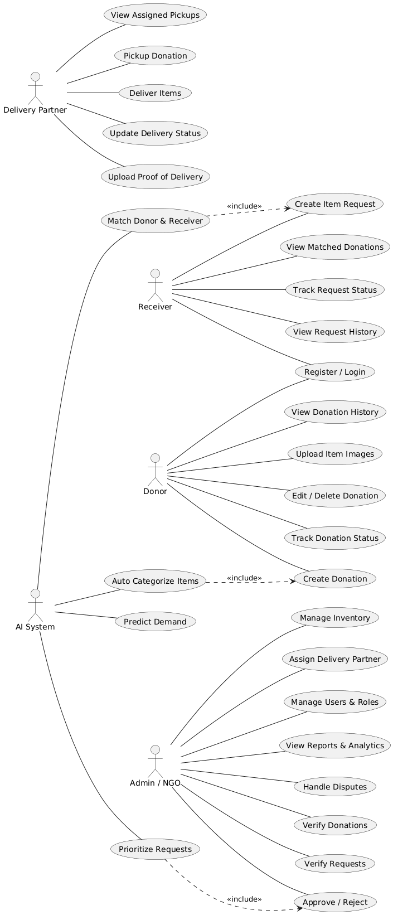
1.2 USE CASE DIAGRAM

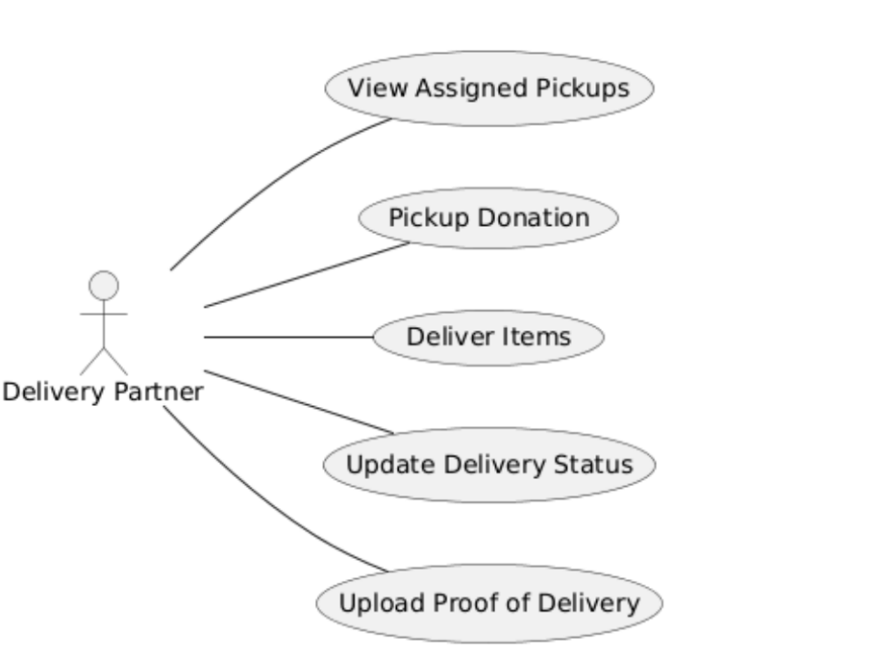

1.3 ACTIVITY DIAGRAM
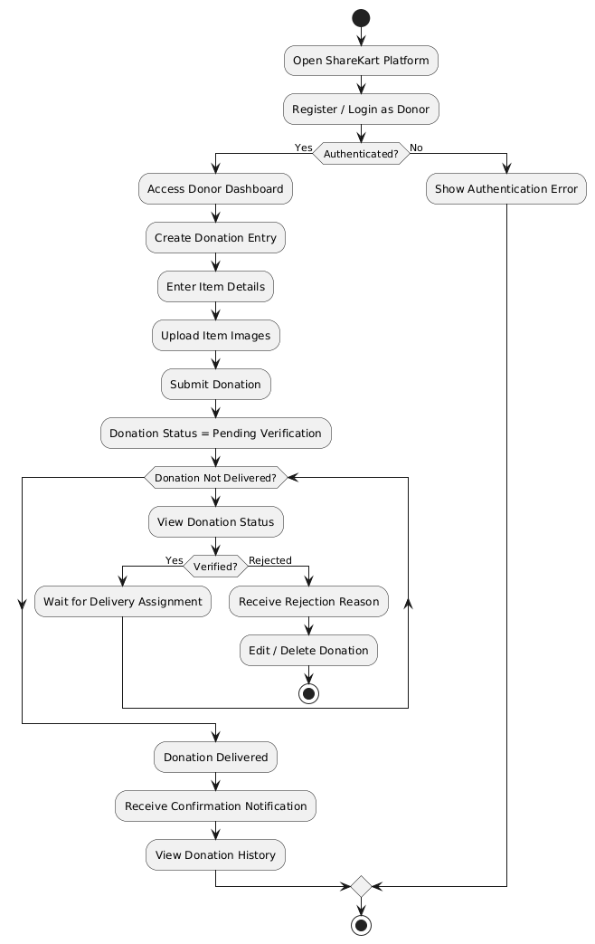
1.3.1 DONOR

1.3.2 RECEIVER
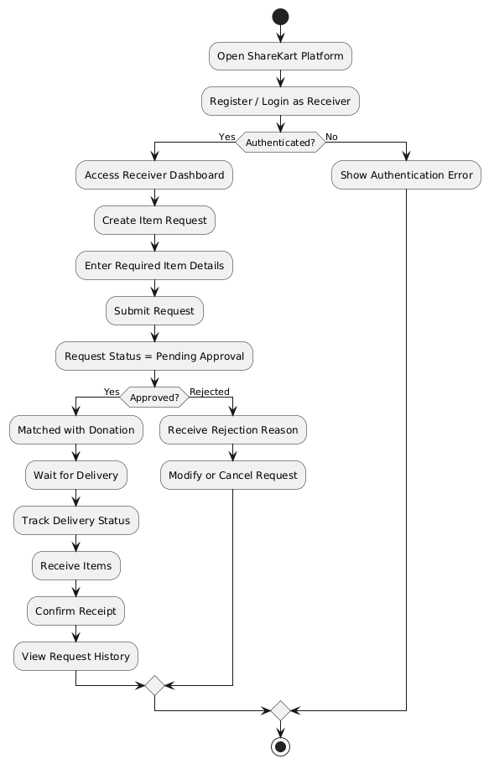

1.3.3 ADMIN
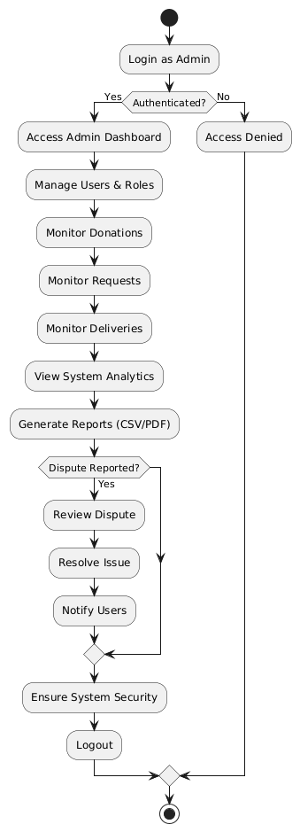

1.3.4 DELIVERY PARTNER
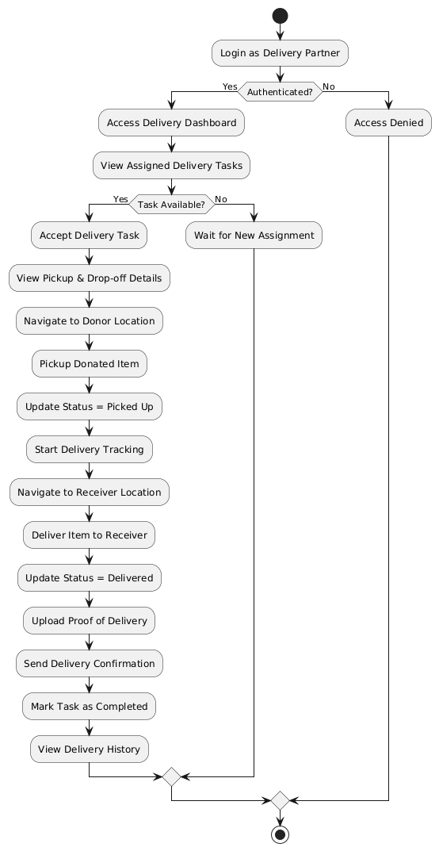

1.4 CLASS DIAGRAM
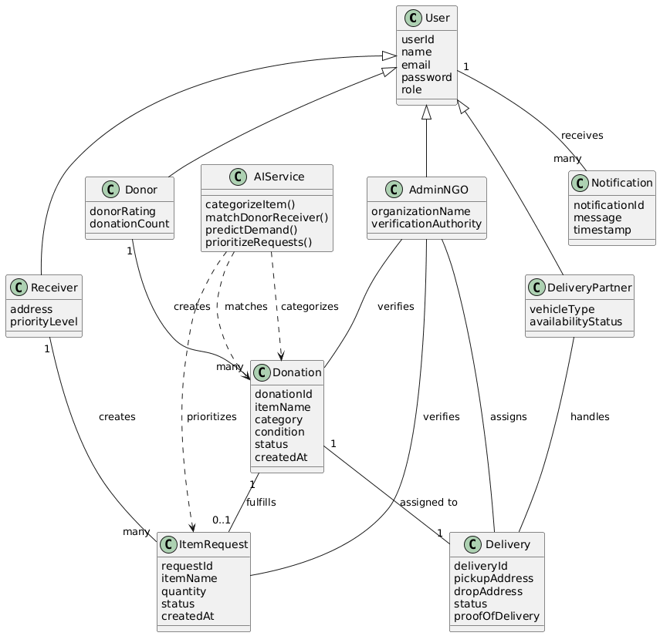

2. DATABASE DESIGN
2.1 USER TABLE
Field Name | Data Type | Description
id | INT (PK) | Unique user identifier
name | VARCHAR(100) | Full name of the user
email | VARCHAR(100) | Unique email address
password | VARCHAR(255) | Encrypted password
role | ENUM | donor / receiver / delivery / admin
phone | VARCHAR(15) | Mobile number (linked to Aadhaar OTP)
address | TEXT | Residential address
aadhaar_verified | BOOLEAN | Aadhaar OTP verification status
aadhaar_verified_at | TIMESTAMP | Date & time of OTP verification
verification_method | VARCHAR(30) | OTP
is_active | BOOLEAN | Account activation status
created_at | TIMESTAMP | Account creation timestamp

2.2 DONATION TABLE
Description | Field Name | Data Type
Unique donation ID | id | INT (PK)
Donor user reference | donor_id | INT (FK → users.id)
Donation title | title | VARCHAR(100)
Item description | description | TEXT
Food / Clothes / Books etc | category | VARCHAR(50)
Number of items | quantity | INT
pending / verified / assigned / picked / delivered / rejected | status | ENUM
Donation created time | created_at | TIMESTAMP

2.3 DONATION IMAGES TABLE
Description | Field Name | Data Type
Image ID | id | INT (PK)
Donation reference | donation_id | INT (FK → donations.id)
Image file path | image_url | VARCHAR(255)

2.4 RECEIVER REQUEST TABLE
Description | Field Name | Data Type
Request ID | id | INT (PK)
Receiver reference | receiver_id | INT (FK → users.id)
Requested item category | category | VARCHAR(50)
Request description | description | TEXT
Quantity required | quantity | INT
pending / approved / matched / rejected / fulfilled | status | ENUM
Request date | created_at | TIMESTAMP

2.5 VERIFICATION LOG
Description | Field Name | Data Type
Verification ID | id | INT (PK)
Donation reference | donation_id | INT (FK → donations.id)
Request reference | request_id | INT (FK → requests.id)
Verifier (NGO/Volunteer) | volunteer_id | INT (FK → users.id)
approved / rejected | action | ENUM
Verification comments | remarks | TEXT
Verification time | verified_at | TIMESTAMP

2.6 INVENTORY TABLE
Description | Field Name | Data Type
Inventory ID | id | INT (PK)
Donation reference | donation_id | INT (FK → donations.id)
Item category | category | VARCHAR(50)
Available quantity | quantity | INT
Stock availability | available | BOOLEAN

2.7 DELIVERY TABLE
Description | Field Name | Data Type
Delivery ID | id | INT (PK)
Donation reference | donation_id | INT (FK → donations.id)
Request reference | request_id | INT (FK → requests.id)
Delivery user | delivery_partner_id | INT (FK → users.id)
Donor pickup location | pickup_address | TEXT
Receiver drop location | drop_address | TEXT
assigned / picked / in_transit / delivered | status | ENUM
Delivery proof | proof_image | VARCHAR(255)
Delivery completion time | delivered_at | TIMESTAMP

2.8 NOTIFICATION
Description | Field Name | Data Type
Notification ID | id | INT (PK)
Target user | user_id | INT (FK → users.id)
Notification content | message | TEXT
Read status | is_read | BOOLEAN
Notification time | created_at | TIMESTAMP

3. TEST CASES
3.1 REGISTRATION MODULE
Test Case ID | Test Scenario | Input Data | Expected Result
TC_REG_01 | Register with valid details | Name, Email, Phone, Password, Role | User registered successfully
TC_REG_02 | Register with existing email | Duplicate email | Error message displayed
TC_REG_03 | Register without mandatory fields | Empty name/email | Validation error shown
TC_REG_04 | Register with invalid email format | abc@ | Invalid email error
TC_REG_05 | Register and complete Aadhaar OTP verification | Valid OTP | Aadhaar verified successfully
TC_REG_06 | Register with invalid OTP | Wrong OTP | OTP verification failed

3.2 LOGIN MODULE – TEST CASES
Test Case ID | Test Scenario | Input Data | Expected Result
TC_LOG_01 | Login with valid credentials | Email + Password | Login successful
TC_LOG_02 | Login with invalid password | Wrong password | Error message displayed
TC_LOG_03 | Login with unregistered email | Unknown email | User not found
TC_LOG_04 | Login without Aadhaar verification | Valid credentials | Access denied
TC_LOG_05 | Role-based redirection | Admin / Donor / Receiver | Redirect to correct dashboard

3.3 DONOR MODULE
Test Case ID | Test Scenario | Input Data | Expected Result
TC_DON_01 | Create donation with valid details | Item, category, quantity | Donation created
TC_DON_02 | Upload donation images | Valid image files | Images uploaded
TC_DON_03 | Submit donation for verification | Donation data | Status set to “Pending”
TC_DON_04 | Edit donation before verification | Updated details | Donation updated
TC_DON_05 | Delete donation before verification | Donation ID | Donation deleted
TC_DON_06 | Track donation status | Donation ID | Status displayed correctly
TC_DON_07 | View donation history | Donor account | Donation list shown

3.4 RECEIVER MODULE
Test Case ID | Test Scenario | Input Data | Expected Result
TC_REC_01 | Create request with valid data | Item, quantity | Request created
TC_REC_02 | Submit request for approval | Request data | Status set to “Pending”
TC_REC_03 | Request approval by NGO | Approved request | Status updated
TC_REC_04 | Request rejection | Invalid request | Rejection reason shown
TC_REC_05 | Track request status | Request ID | Correct status shown
TC_REC_06 | Receive donation | Delivery confirmation | Request marked fulfilled
TC_REC_07 | View request history | Receiver account | History displayed

3.5 ADMIN MODULE
Test Case ID | Test Scenario | Input Data | Expected Result
TC_ADM_01 | Login as admin | Admin credentials | Admin dashboard loaded
TC_ADM_02 | View all users | User list | Users displayed
TC_ADM_03 | Manage user roles | Role update | Role updated successfully
TC_ADM_04 | View donations & requests | System data | Data displayed correctly
TC_ADM_05 | Monitor deliveries | Delivery data | Delivery status shown
TC_ADM_06 | Generate reports | Date range | Report generated
TC_ADM_07 | Resolve dispute | Dispute case | Issue resolved

